Computers 8/9
Ms. Toombs

Learning Objective:
- I can Identify all the functions on a Word Processing screen

Directions:
- Identify all the parts of the word processing screen and write it on the lines below

N
L
C
J
D
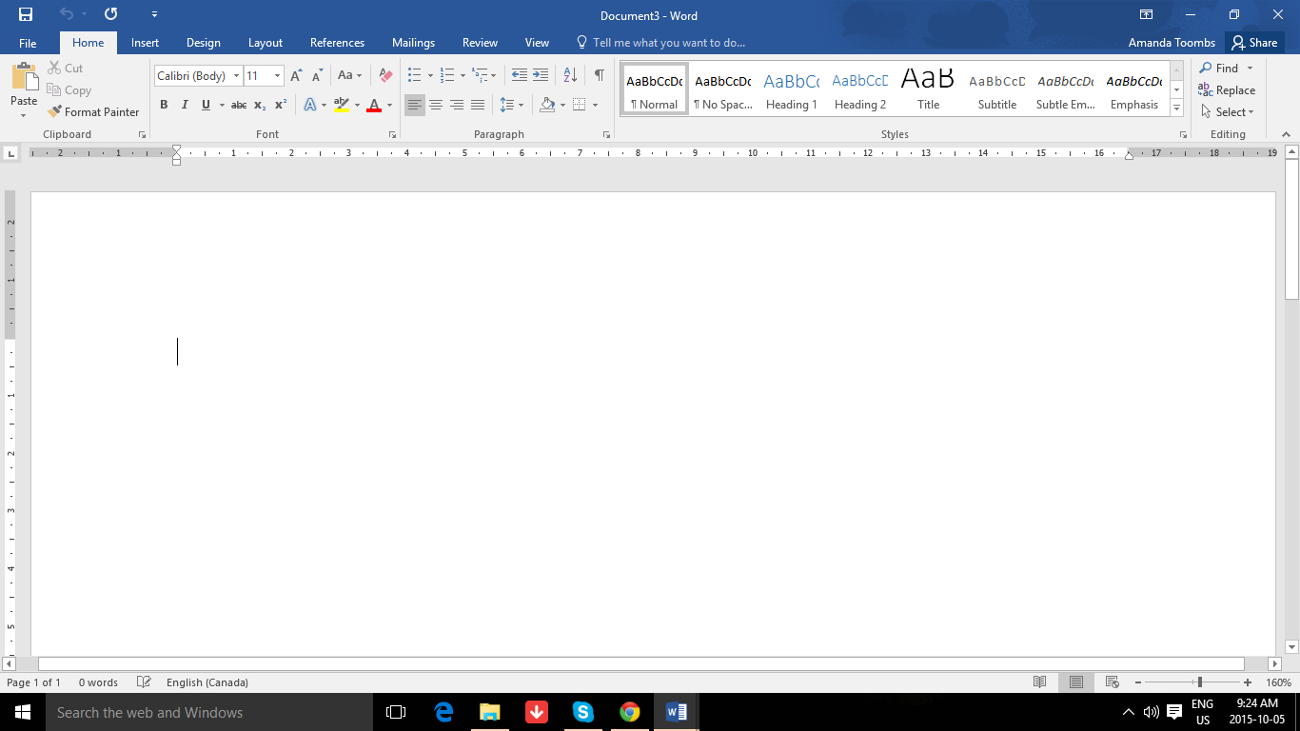
K
B
M
I
H
G
F
E
E
A

A | B | C
D | E | F
G | H | I
J | K | L
M | N | O

