Computers 8/9 – Microsoft PowerPoint
Ms. Toombs

The PowerPoint Screen
Learning Objective:
- I can correctly identify the different parts of the Microsoft PowerPoint Screen.

Directions:
- Use your Mouse to hover over the different parts of the Power Point Screen and put them into the correct box on the table.
- Save to OneDrive and share once finished.

A | B | C | D | E
F | G | H | I | J
K | L | M | N

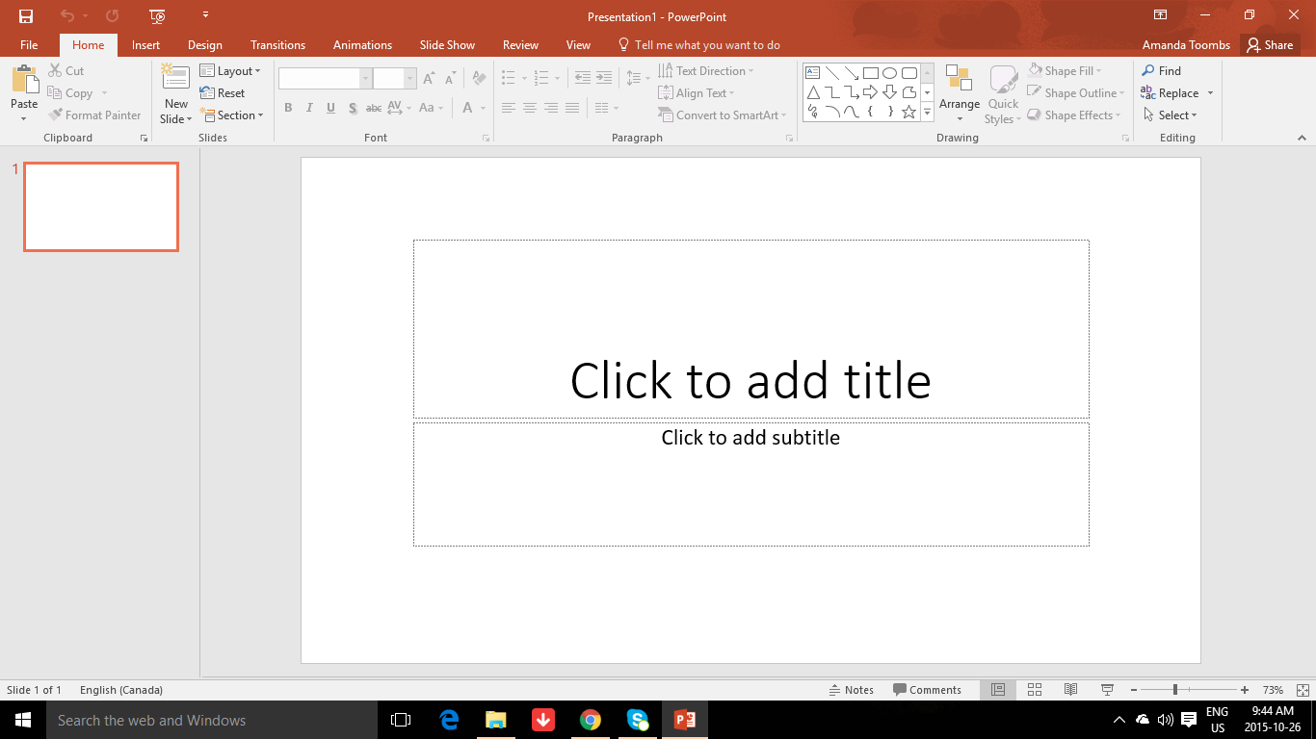
N
M
L
K
J
I
H
G
F
E
D
C
A
B

