Computers 8/9
Ms. Toombs
Microsoft Excel – Microsoft Excel Screen

Learning Objective:
- To identify the different functions on the Microsoft Excel Screen.

Directions: Using the Arrows on the screen, identify the parts of the Microsoft Excel screen.
A | E | I C
B | F | J
C | G
D | H
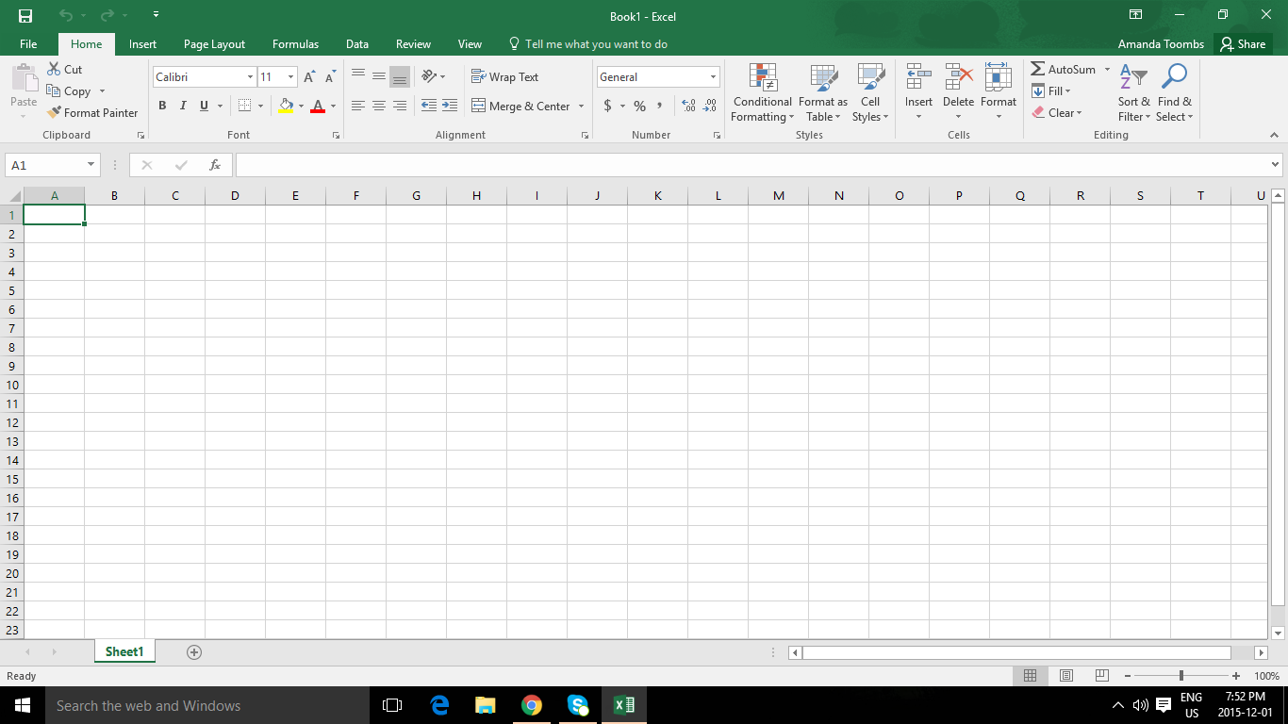
J
I
H
G
F
E
D
C
B
A

