Computers 8/9
Microsoft Excel

In this exercise:
- Understanding of rows and Columns
- Typing and editing text in a cell
- Formatting text in a cell
- Using the series to fill Handle

- Click on the first cell. This is called cell A1 (Because it is row 1 and column A
- Type your first name. See how your name shows up in the cell and in the Formula bar.
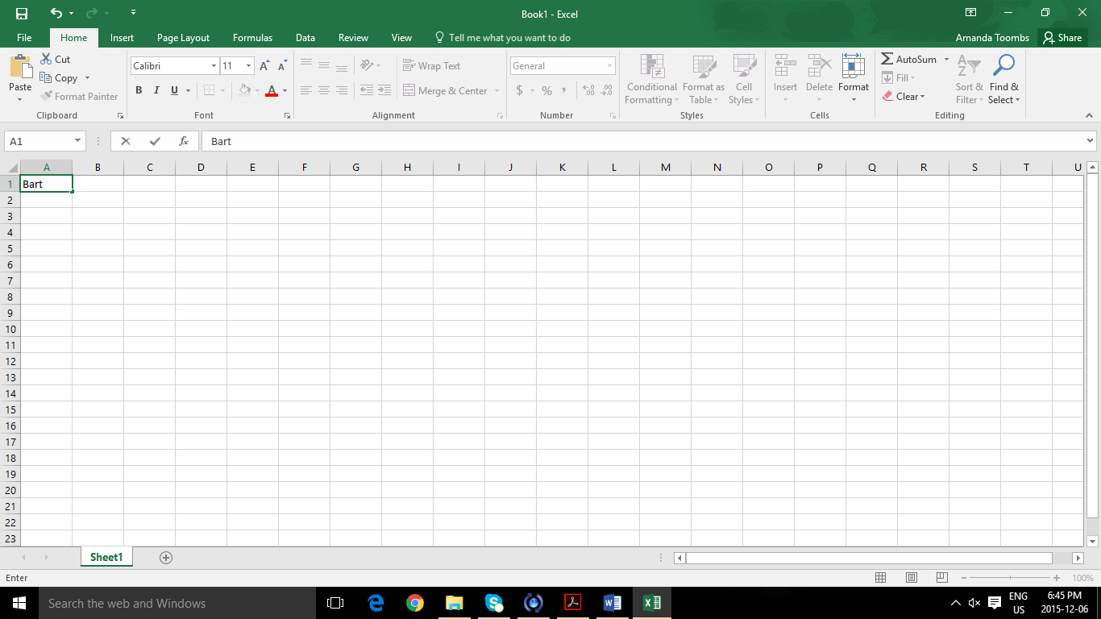
This is the formula bar
This is a Cell
- Press the ENTER key. This will move the cursor to the cell below A1
- Click on cell A1 again to select it
- Click on the formula bar. Click after your first name. Now, type your last name. You should always make changes in the formula bar. If you try to make changes in the cell you will type over what is already there.
- Press the ENTER Key. Now you are in cell A2.
- Type the words Happy Birthday. See that the words don’t quite fit in the box. Don’t worry about it. See that the text is also in the Formula bar.
- Press the ENTER key. The cursor will move to the cell below it. Some of the text might be hidden but is not gone.
- Click on cell A2 again your text will return.
- Now click on cell B2.
- Type the words dear Lisa.
- Click in cell B2. Click in the formula bar and change Lisa to Lizel.
- Move the cursor to the line between columns A and B. It should look like this:
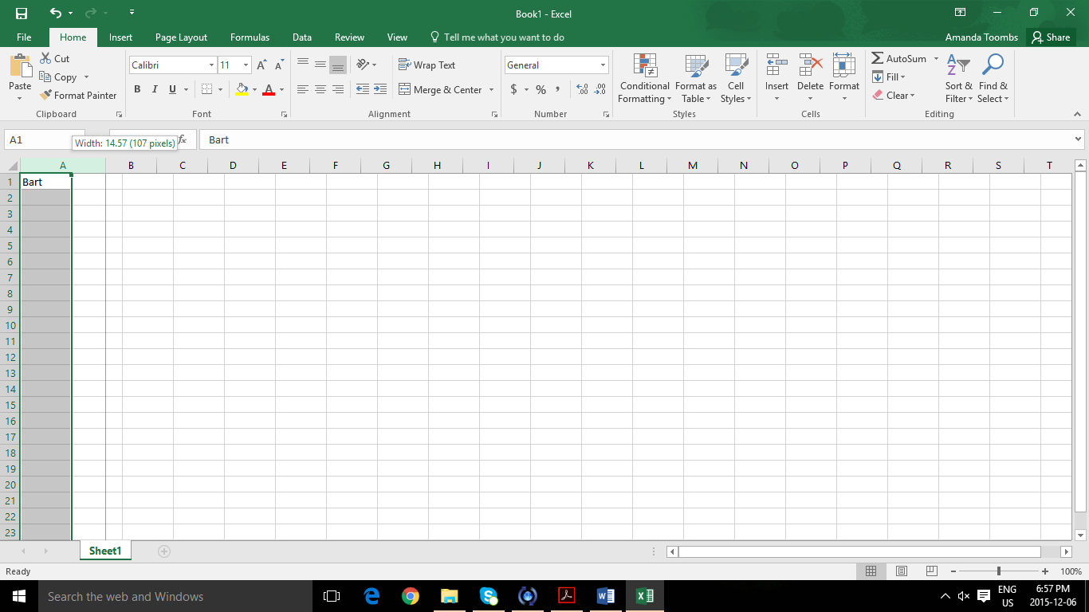
Click on the column and a cursor should appear near the edge of the column and drag it to make it appear.
- Click and drag to make the column bigger.
- Repeat this between columns B and C. You can resize rows the same way.
- Click on the Undo button or click and drag until the columns are back to the normal size.
- Place the cursor between columns A and B. Now double click and the column will be as wide as the longest number or text in that column.
- Resize Column B in the same way.
- Click and drag across the cells and select them. Select all of the cells with text.
- When the cells are selected. Press the DELETE key. Everything should be erased.
- Click in cell A1 and type This is cell A1.
- Use the TAB key to move to cell B1 and type This is cell B1.
- Move into cell C1 and type This is cell C1.
- Using your arrow keys, move to cell A2 and type This is cell A2. Move into cell B2 and type This is cell B2. Move into cell C2 and type This is cell C2
- Select all of the text and change the font to Times New Roman 14 pt. Bold the text.
- Double click between the column labels to resize all of the columns.
- Cell A8 Type January. Look for a little green square at the lower right corner of the cell. This called the fill handle. Carefully move your cursor over the fill handle. Your cursor should change from the select mode to a small black cross (autofill cursor).
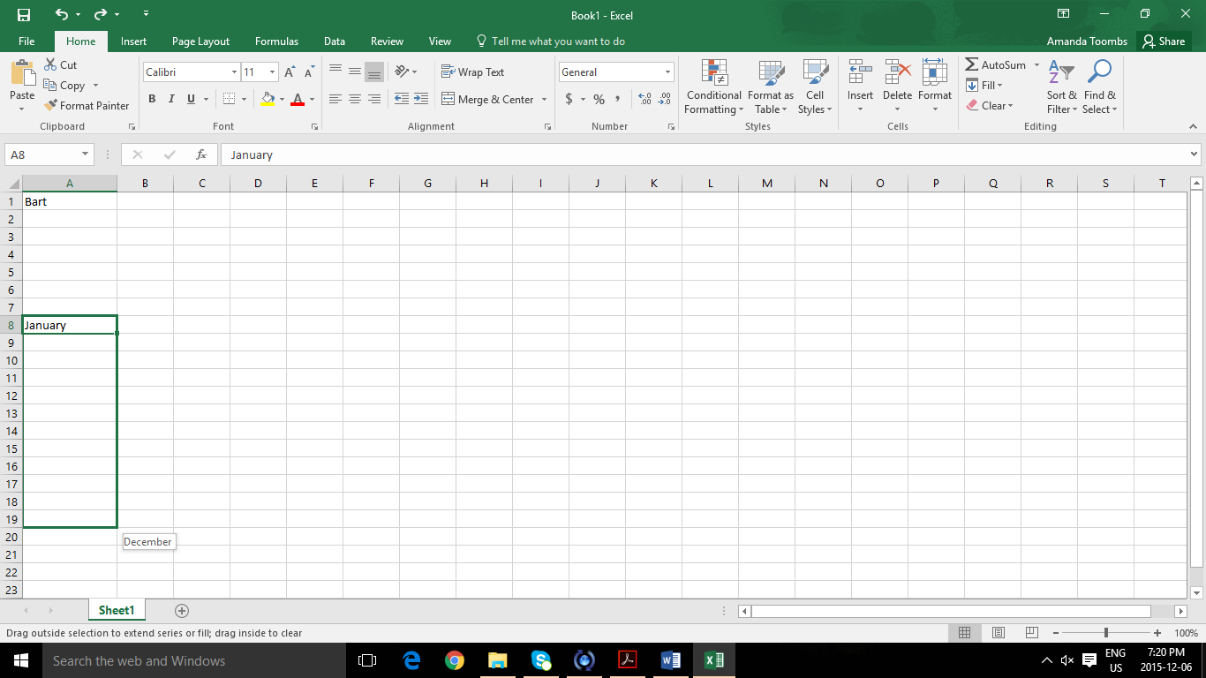
- Click on the fill handle and drag it down to A19.
- You will see the 12 months of the year in column A.
- Click in cell B8 and type the word Monday.
- Drag the black box called the fill handle and down to B14. You will see the seven days of the week in column B.
- Click in cell C8 and type the date 10/10/15. Use the fill handle to add the dates that come after it.
- Save this file to your OneDrive. Name it Excel 1. Share with the teacher.

