Create a Business Website Assignment
As an up and coming web designer, a company has approached you to design and fabricate a website for them. This company needs a new Website to improve their image. Will be redesigning a website for your chosen Business employer. Using Weebly for Education, design a website for your client.
- You may decide which business/website you would like to use but you must base your business plan entirely on that particular site.
- All Parts of the assignment must be submitted to get a mark.
- Please provide the teacher with the link, username and password of the website
Part 1 Plan your Business
- Create a business plan in Microsoft Word.
Make sure that you include the following points (Give as much information as possible)
- Type of business (sales, service, entertainment, band, club, team, etc.)
- Purpose of the business (What does your company do?)
- Location- Street, city, etc. (Should be fictitious unless you are working on a real website)
- Contact information- phone email (should be fictitious unless you are working on a real website)
- Type of location (rented office space, modern store etc.)
- Who is your target audience? Who are you advertising for?
- What products or services does your company offer?
- What are your business hours of operation?
- How many employees do you have? You must have at least 3. What specific positions will these employees hold?
- Why do you think your business will succeed?
- Identify the competition in your business area and location.
- Any other relevant information?

Business Proposal Website
Category | 4 | 3 | 2 | 1
Organization | Information is very organized with well-constructed paragraphs and subheadings. | Information is organized with well-constructed paragraphs. | Information is organized, but paragraphs are not well-constructed. | The information appears to be disorganized.
Amount of Information | All topics are addressed and all questions answered with at least 2 sentences about each. | All topics are addressed and most questions answered with at least 2 sentences about each. | All topics are addressed, and most questions answered with 1 sentence about each. | One or more topics were not addressed
Content and information | Students have included all of the required information and content, and have gone beyond to include additional text and/or information that contribute to the overall quality of the document. | Students have included most of the required information and content with some omissions. OR The students did not include additional text or information to enhance the quality of the  document |  | Several required areas of information have been omitted.
Mechanics | No grammatical, spelling or punctuation errors | Almost no grammatical, spelling or punctuation errors. (1-2  Errors) | A few grammatical spelling, or punctuation errors. (3-4 errors.) | Many grammatical, spelling, or punctuation errors. (5 or more errors.)
Professionalism | The final outcome of the document looks "fit for the shelf." | The final outcome of the document looks fairly good, but the document could use some minor improvements |  | The document looks unprofessional and needs major revisions and improvements.

Part 2 Plan your website
- Use Word to create a hierarchy chart of your website – it should show the title of each page, and list the contents of each page (This will be as you find it on their website)
Your Home Page is the introduction you your business and it should contain the following
- Business name
- Business location, contact information and hours
- A Graphical logo and an Advertising slogan (Design it yourself)
- Something to “Catch” their attention
- Carefully selected graphics
- Business owner (fictitious), web author and date created
Keep in mind the following when planning the content of your other pages:
- What is the purpose of your website (to advertise, to sell, information?)
- What do you need to include in your website to appeal to your target audience?
- What can you use to catch people’s eyes?

Sample Hierarchy Chart
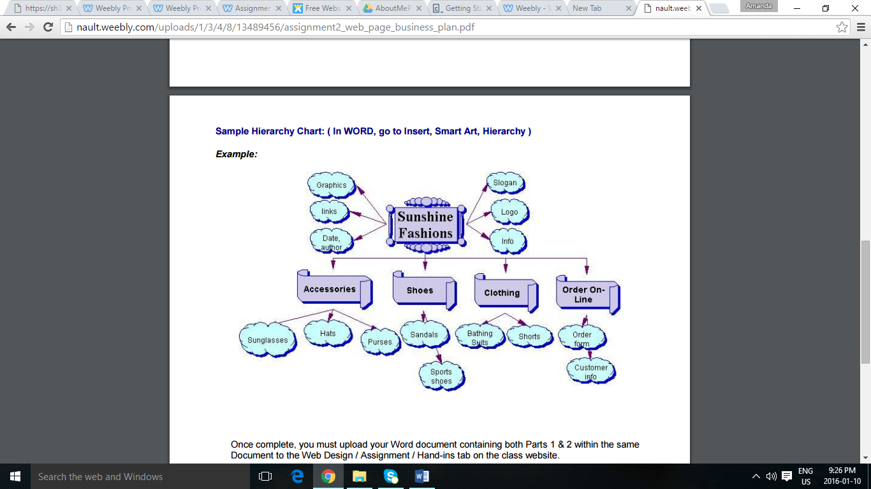

Once you complete Parts 1 and 2 of the assignment, please include your word documents as a link in your Website.

Points to include in your Webpage:
- You need to have one home page and five (5) other pages. Make sure this is reflected in your hierarchy
- Make sure you have a logo. Design this in either Microsoft Word or Paint.
- Copies of your work completed in Microsoft Word.
- Make sure that your business is fictitious.
- Please include four elements found on the left hand side of the Weebly menu. This can include:
  - File
  - Calendar
  - Slideshow
  - Poll
  - Survey
  - Map
  - Contact Form

Category | 4 | 3 | 2 | 1
Background | Background is exceptionally attractive, consistent across pages, adds to the theme or purpose of the site, and does not detract from readability. | Background is attractive, consistent across pages, adds to the theme or purpose of the site, and does not detract from readability. | Background is consistent across pages and does not detract from readability. | Background detracts from the readability of the site.
Color Choices | Color choices form a pleasing palette, do not detract from the content, and are consistent across  Pages | Color choices do not detract from the content, and are consistent across pages. | Color choices detract from the content | Color choices make the content hard to read or otherwise distract the reader.
Fonts | Excellent choices. | The fonts are consistent, easy to read and point size varies appropriately for headings and text. | The fonts are consistent and point size varies appropriately for headings and text. | Font sizes and/or styles are difficult to read and detract from the site
Graphics | Graphics are related to the theme/  purpose of the site, are thoughtfully cropped, are of high quality and enhance reader interest or understanding | Graphics are related to the theme/purpose of the site, are of good quality and enhance reader interest or understanding. | Graphics are related to the theme/purpose of the site, and are of good quality. | Graphics seem randomly chosen, are of low quality, OR distract the reader.
Spelling and Grammar | There are no errors in spelling, punctuation or grammar | There are 1-3 errors in spelling, punctuation or grammar. | There are 4-5 errors in spelling, punctuation or grammar. | There are more than 5 errors in spelling, punctuation or grammar
Content | The site has a well-stated clear purpose and theme that is carried out throughout the site. | The site has a clearly stated purpose and theme, but may have one or two elements that do not seem to be related to it. | The purpose and theme of the site is somewhat muddy or vague. | The purpose and theme of the site is somewhat muddy or vague.
Layout | The Web site has an exceptionally attractive and usable layout. | The Web pages have an attractive and usable layout. | The Web pages have a usable layout, but may appear busy or boring. It is easy to locate most of the important elements. | The Web pages have a usable layout, but may appear busy or boring. It is easy to locate most of the important elements.
Navigation | Links for navigation are clearly labeled, consistently placed, allow the reader to easily move from a page to related pages (forward and back), and take the reader where s/he expects to go. A user does not become lost. | Links for navigation are clearly labeled, allow the reader to easily move from a page to related pages (forward and back), and internal links take the reader where s/he expects to go. A user rarely becomes lost | Links for navigation take the reader where s/he expects to go, but some needed links seem to be missing. A user sometimes gets lost | Some links do not take the reader to the sites described. A user typically feels lost.

