Directions: Click on the following link: http://www.gcflearnfree.org/computerbasics/5
View the video and read the lesson Basic Parts of the Desktop Computer, then correctly label the parts of a desktop computer. To label the parts, click on a label and drag it to the correct blank.
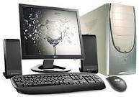

Labels:
Monitor
Mouse
Tower Case
Speaker
Keyboard

