Computers 8/9 ~Microsoft Office
Ms. Toombs
Oct 13

Exercise 7:
Task:
Create your own ad for the company you created. Try to make it funny. Use the instructions below to complete your ad.
Instructions:
- Type the flyer text, unformatted, as shown in the example on page 2. After you have typed the text apply the formatting as indicated in the steps below.
- Save the document using the file name. “Company Name Your Name”
- Change the theme fonts to the Niagara Solid font.
- Insert Title using Word art
- Center Word Art.
- Place a picture behind the title of your flyer.
- Change the font and the font size of the headline to 48 point Arial rounded MT Bold.
- Change the font size of the body between the headline and the signature line to 22 point.
- Change the font size of the signature line to 28 point
- Bullet the three lines (Paragraphs) of text above the signature line.
- Bold details about your company.
- Italicize a word that you want to emphasize.
- Add a border to your page.
- Underline the word and, and in the first bulleted paragraph. In your bullets provide details about your company.
- Change the spacing before the headline to 1.0 point for all of the document.
- Insert the picture and center it.
- The entire flyer should fit on a single page. If it flows to two pages, resize the picture or decrease spacing before and after paragraphs, until the entire flyer text fits on a single page.
- Save flyer again and share with the instructor.

Heading line
Select image and insert Word Art (Do in this order)
Queasy Air
Gain an entirely new vision of Williams Lake by taking the ultimate loop-de-loop tour. Visitor or local, business or pleasure, the trip will change our view of the city.
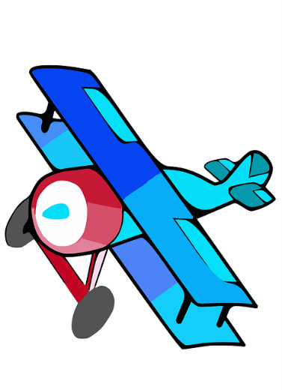
Under design tab insert page border
Right click on mouse select style and put a border around your image.
- Pilots are not licenced and have little experience.
- 3 hour tours available during night time tours.
- FREE!
CALL QUEASY AIR AT 250-392-1234!
Signature line

